ERYA Bulk

User Guide & Tutorial

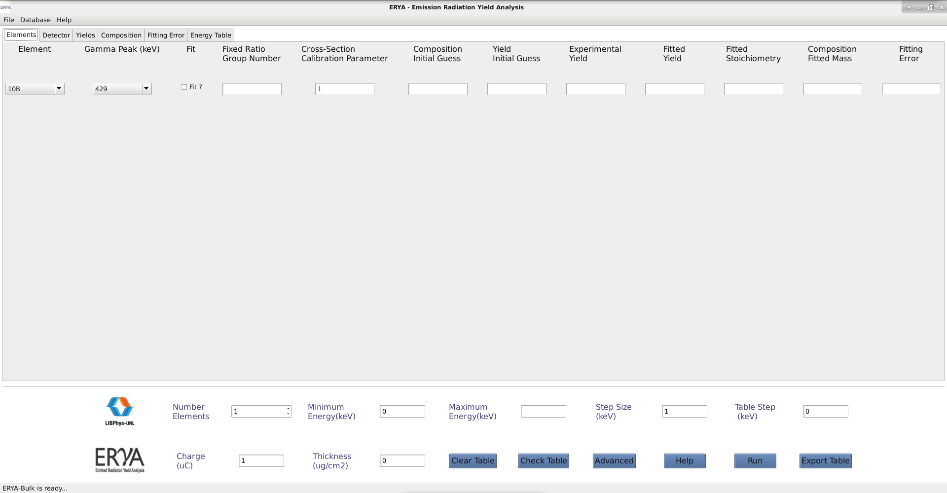

**Contents**

**Introducing ERYA:**

*Welcome!*

*Physical Theory of Gamma Ray Emission Yield Analysis*

*What’s New on ERYA Bulk?*

*Quick Start!*

*Changing Setup Settings*

*Setup Troubleshooting Guide*

**Explore the Database Management Tools:**

*Detector Efficiency*

*Ziegler Parameters*

*Element Database*

**How to Make a Stoichiometric Analysis:**

*How to define your Sample*

*Advanced Fitting Parameters (Optional)*

*A Common Example*

**Bibliography:**

**Introducing ERYA Bulk**

**Welcome!**

ERYA (Emitted Radiation Yield Analysis) Bulk is a software application designed to aid the PIGE analysis of bulk samples (i.e. in-depth homogeneous samples), when the main task is to determine their composition in terms of their elements and/or isotopes quantities.

PIGE refers to Particle (mainly protons) Induced Gamma-ray Emission, resulting from nuclear reactions between the sample and the impinging particles. As the cross sections related to these reactions, at proton energies in the range 2- 5 MeV, favor nuclear reactions in the lighter isotopes, PIGE deals mainly with light element analysis.

The ERYA code calculates the elemental concentrations from ab-initio principles, surpassing the need of a comparative method based on standards, and achieving quick and easily the pretended results.

The performance of PIGE analysis based on this software depends on the physical model, experimental setup and measurement accuracy.

ERYA-Bulk was developed at LibPhys-UNL, hosted by *Departamento de Física* (Physics Department)of the *Faculdade de Ciências e Tecnologia* (FCT) - *Universidade Nova de Lisboa* (UNL), postal code address 2829-516 Caparica, Monte da Caparica, Portugal.

ERYA-Bulk was programmed by Vasco Manteigas vm.manteigas @ campus.fct.unl.pt, with advice from Micaela Fonseca (micaelafonseca@fct.unl.pt), and also the original programmer of the previous LabView ERYA version.

ERYA is available for Windows, Linux and Mac OS X platforms.

The program contains on-line help reference, which complements the present manual.

**Physical Theory of Gamma Ray Emission Yield Analysis**

The program evaluates the composition of a homogeneous sample, although it may be made from a mixture of several elements, by evaluating the corresponding nuclear reaction induced gamma-ray yields.

For a very thin target (meaning one for which the energy loss of the incoming beam is small), the yield corresponding to an isotropic gamma-line may be written as:

$Y\left(E\right)=ε_{\text{abs}}\left(E_{γ}\right).n_{p}.σ\left(E\right).N_{i}.∆x$ (1)

where εabs(*Eγ*) is the detector efficiency corresponding to the gamma-ray emission energy,np is the number of incident protons, *σ*(*E*) are the cross section at incident energy *E* of the relevant nuclear reaction, *Ni* is the number of nuclei of the relevant isotope per volume unit and *Δx* is the target linear thickness. For a thick target, the above equation still applies for each thin layer parallel to the target surface (for normal incidence). For each layer of linear thickness *dx* or mass thickness (mass per surface unit) *dx*, we may write a similar equation that may be expressed in terms of the relevant element mass fraction *fm*:

(2)

being *Nav* the Avogrado number and *fi*, and *A* the isotopic abundance and the atomic mass of the relevant element, respectively.

The thick target yield results from the integration over the range of the protons in the target, *R*, of the above equation:

$Y\left(E\right)=ε_{\text{abs}}\left(E_{γ}\right).n_{p}.{f_{m}.f}_{i}.N_{av}.A^{−1}\int_{0}^{R}{σ\left(E\right)}dΓ$ (3)

or: $Y\left(E\right)=ε_{\text{abs}}\left(E_{γ}\right).n_{p}.{f_{m}.f}_{i}.N_{av}.A^{−1}\int_{0}^{E_{0}}{σ{\left(E\right)}/{S_{m}}\left(E\right)}dE$ (4)

where *E0* is the incident energy of the beam and *Sm(E)* represents the mass stopping power, expressed in energy per areal mass units, related to the influence of the sample composition on the incident beam.

In order to get the mass fraction from a given yield, it is required to know the major composition of the target which affects the stopping powers. From a first guess of this composition, ERYA provides the tools to optimize the composition in order to fit the calculated yields to the experimental ones.

A more detailed description of the physical theory can be obtained from the own program’s online help reference.

**What’s New on ERYA Bulk?**

This application is a full rewrite of a previous LabView program that handles the PIGE measurements of a bulk homogeneous sample (hence the ERYA-Bulk program name).

The new ERYA is now fully implemented on C++ language, while the core framework, including the Graphic User Interface, is derived from a cross-platform library called wxWidgets.

wxWidgets is an open-source framework inspired on the Microsoft Foundation Classes, and compliant with the Standard Template Library, extending the compatibility to several operating systems and computer architectures, easing the port to several systems.

The new ERYA Bulk is available for Windows, Linux and Mac OS X, with support of most common architectures.

Windows and Linux versions are available for 32 and 64-bit Intel/AMD versions, where the 64-bit versions is the recommended version. It was tested on Windows 7 and 10, and runs without issues.

Mac OS X are only available for 64-bit x86-64 Intel architecture, since Apple guidelines strongly discourage a 32-bit version. ERYA will not check Mac OS X version, but it was reported to work on Mac OS X 10.10 until 10.14 versions.

A special build for 32 and 64-bit ARM machines are also available for Linux computers, and are dedicated for ARM computers like the Raspberry 3 models.

All Linux packages are designed to work with any Debian derived Distribution, as long it contains the wxWidgets 3.0.4 libraries updated. It requires at least Debian 9 Stretch with backports repositories enabled, or Ubuntu 18.04 LTS versions to work.

In order to ease ERYA use, some sample databases are bundled on every ERYA package. It contains a ready to use Element’s Database, three stopping-power database files (for Ziegler’s and SRIM parameters), and a Detector Efficiency profile.

ERYA contains import tools intended to convert several source files (IBANDL, SRIM, plain text files, … ) to the native ERYA database file formats.

►This manual and the on-line help documentation contains all references and correct procedures to import correctly. Read carefully all manual forehand.

**Note:** If you are interested to contribute to maintain the wxWidgets ERYA Bulk source-code, or any issue related to the program use, please contact the programmer by it’s e-mail.

The ERYA-Bulk main window interface:

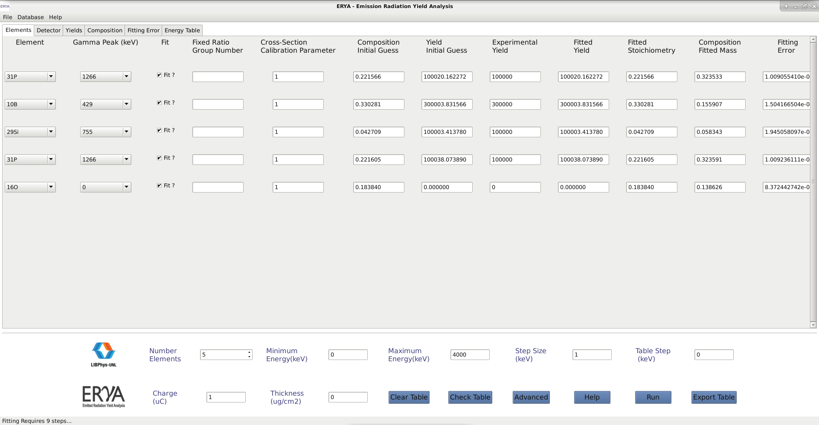

At a technical level, the major features are:

1. A new unified Database format for the Elements, the Detector Efficiency and the Ziegler Parameters, which uses the standard XML document format, given flexible data storage, an hierarchical data content structure, and a more standardized method to read and write the contents.

2. New file filter imports for IBANDL files, SRIM files, generic spreadsheet-like ASCII source files and Excel 2007 (and beyond) Xlsx files, in order minimize the steps needed to convert the original data to the native ERYA database structures.

3. An on-line help, based on HTML pages, and directly accessed by the program, which explains the main program features, and major tasks.

**Quick Start!**

The installation of ERYA on any supported operating system is straightforward.

Select the adequate package which matches your operating system and architecture, and download it to your computer. As a rule of thumb, Linux versions should have the *amd64, i386, arm64, armhf* suffixes (first half are for Intel, and later half are for ARM machines.). Windows versions are identified with *win64* or *win32* versions. Mac OS X version are identified by *osx* suffix.

**Windows:** All Windows packages contains the wxWidgets libraries and GNU C++ Runtime Library inside the executable package. The installation wizard program will install ERYA to the default Program Files folder, and will create a Start Menu entry.

**Linux:** Linux versions of ERYA are available on Debian package format (deb), and any Linux distribution compatible with Ubuntu 18.04 LTS or Debian 9 Stretch will install automatically.

► It is highly recommendable to use the apt/dpkg package manager from the Terminal application to minimize potential installation errors, even some Linux distributions had GUI tools:

$ **sudo apt update** (Refresh the repositories)

$ **sudo apt dist-upgrade** (Update manually your system)

$ **sudo dpkg -i *.deb** (Install the package)

$ **sudo apt -f install** (Install the missing libraries from your Linux repository.)

► Debian distributions have more tight security features, and require to open a root shell from Terminal:

$ **su** (And type your root password)

# **apt update** (Refresh the repositories)

# **apt dist-upgrade** (Update manually your system)

# **dpkg -i *.deb** (Install the package)

# **apt -t stretch-backports -f install** (When using Debian 9 Stretch)

**Warning:** ERYA was not tested on Linux distributions tailored to perpetual beta staging, like Arch Linux or their derivatives.

**Mac OS X:** For Apple Macintosh, once downloaded the Mac OS X package and unzipped it, the users just need to copy the ERYA-Bulk.app package to the Applications folder. Finally, click on ERYA-Bulk icon to run the software on Mac OS X.

**Uninstall ERYA:**

To remove ERYA from your system completely, follow this instructions:

**Windows:** Open the list of installed programs on Control Panel (usually, the path is: Start Menu > Control Panel > Programs and Features).Once the program list is loaded, select “ERYA-Bulk”. It will ask whether to uninstall the program, and answer “Yes”.

To remove any program profiles, open a Command Prompt (cmd), and execute the command:

$ **rmdir -s** **C:\users\name\Local Settings\Application Data\ERYA-Bulk-Win64\** (64-bit)

**$ rmdir -s C:\users\name\Local Settings\Application Data\ERYA-Bulk-Win32\** (32-bit)

**Linux:** Open a Terminal application and type the following commands:

$ **sudo apt remove eryabulk**

$ **rm -rf ~/.ERYA-Bulk**

**Mac OS X:** Delete the application from the Applications folder on your system.

Open the Terminal.app and execute the following command:

$ **rm –rf ~/Library/Application Support/ERYA-Bulk-OSX/**

**Note:** Read the Setup and Troubleshooting sections for solution to the most common issues, before contacting ERYA’s author for help.

**Initial Setup**

Once ERYA-Bulk is successfully installed, it will need a configuration file in order to work properly.

When ERYA-Bulk starts for the first time, the program will start a wizard to guide the user to configure the software properly.

The wizard will ask the user to select from the bundled database files, which ones will be the Element Database, Detector Efficiency and Ziegler Parameters databases. While it is possible to skip the wizard, it is not recommendable to use ERYA without any loaded databases.

Once selected all necessary files, the wizard will ask the user to select a local or portable profile.

The key differences are displayed on this table:

|  |  |  |  |
| --- | --- | --- | --- |
| **Operating System** | **Windows** | **Linux** | **Mac OS X** |
| **Portable Setting** | **In the same program directory** | | |
| **Local User Profile** | **C:\users\name\Local Settings\Application Data\ERYA-Bulk-Win64\\*** | **/home/name/.ERYA-Bulk/\*** | **/Users/name/Library/ Application Support/ERYA-Bulk-OSX/\*** |
| **Config Name** | **ERYA-Bulk-Win64.conf** | **ERYA-Bulk.conf** | **ERYA-Bulk-OSX.conf** |

**Portable Setting:** Once the configuration file is written on the root program directory, the setup is complete. Any changes on default Detector, Elements and Ziegler will overwrite the original ones used by the program, since the same working directory was chosen.

**Local User Profile Setting:** This is the recommendable configuration, since the wizard will store a copy of the default Database, Ziegler and Detector files on the directory defined on the previous table. Even if the user change the local copies of databases, the original program ones are left unchanged, being available as an informal backup allowing a program reset in case of a serious error.

**In the End:** Once all wizard steps are done, the configuration file is created and tested. If ERYA do not find any problems during the Databases loading phase, the main GUI interface will appear.

**Warning:** If ERYA delivers an error message about invalid or corrupted databases, please read the Troubleshooting chapter of this manual.

**Running ERYA for the First Time**

**1.** When ERYA-Bulk runs for the first time, it will display a warning that no configuration file was found, triggering the Setup Wizard. In case of a previous ERYA-Bulk installation, the program will load the old configuration file, and the associated databases. To avoid this, read the *Initial Setup* section to delete manually any previous configuration file, and restart these steps.

**2.** If no previous configuration file exists, ERYA will start a wizard, guiding the user for the next steps.

**3.** ERYA’s wizard will ask the user to select the start-up Element Database from the ERYA’s package. Normally the file opening dialog will point to the program directory, and here the user should select the file with an **epd** extension.

**4.** The same logic will apply for the Detector Profile file, again with an **epsd** extension.

**5.** Finally, choose the file for the Stopping Powers, with an **epsz** extension. ERYA’s package contains at least three versions (including the converted SRIM tables, that is the recommend one), leaving to the user to choose among them.

**6.** At the last wizard page, the user can select the profile setting:

- Local (default) folder profile;

- The program root folder profile.

It is highly recommendable to select the local profile setting, as explained before.

**7.** Once the user finishes the wizard, it will create the necessary configuration files on the target directory, taking only a few seconds to complete.

**8.** ERYA-Bulk is now ready to use, unless an error occurs (see the Troubleshooting section for additional details). The main GUI is loaded automatically on screen.

► On next start-ups, the program will load the configuration file automatically, and the main GUI starts without additional user input.

**Warning:** In case of any errors related to the databases or configuration files, read the *Troubleshooting* guide to resolve them.

**Changing Setup Settings**

When needed, the user can change any start-up databases at any time, and ERYA provides a tool accessible from Database > Setup Default Databases menu.

The actual configuration will be displayed on the different widget controls:

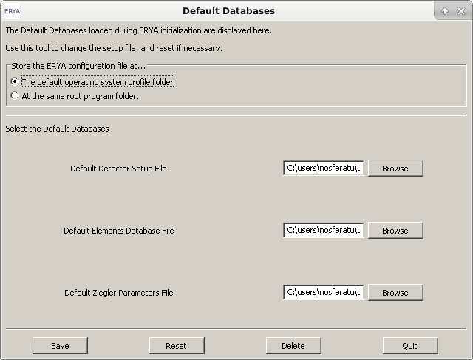

► Once the parameters are changed, select the following buttons to:

“Save” will create a new configuration file directly.

“Reset” will clear the widget contents, without affecting the actual configuration.

“Delete” will delete all configurations, and force to start a new Setup Wizard.

“Quit” will close the widget leaving the actual configuration untouched.

**Tip:** To erase all damaged configuration files, and local copies of ERYA’s databases, select the *Delete* button. This will replace the need of a manual deletion of the local profile folder described on the *Quick Start* chapter.

**Setup Troubleshooting Guide**

► This chapter is a quick guide to fix some common problems that can occur with the utilization of this software.

**1. ERYA warns with a message as “Invalid Database”, where one or all databases are absent or cannot be loaded at all.**

**►**At top menu, select Database > Setup Default Databases, and select the correct files.

- If the problem persists, select “Delete” to delete all local data, and start a new Setup Wizard (all custom changes will be lost!)

**-** Alternatively, delete the configuration files and profile folders manually.

**-** Avoid to use third-source database files to perform a clean installation, since it could be the source of problems.

**2.**  **ERYA cannot write any file, even the configuration file, on certain folders.**

► This problem occurs when ERYA is trying to write on a protected folder that requires additional privileges. To solve this problem, select other folder that does not require special permissions.

**-** Warning: the user should not run ERYA-Bulk with administrator privileges, in order to improve stability and security!

**3. ERYA’s dialog sizes are too small/big.**

**- Label’s font size on dialog are too tiny or cropped.**

**- The whole interface does not fit to the computer screen.**

**►** ERYA GUI’s code relies on the automatic window sizing delivered by the wxWidgets framework, but in some cases, issues are inevitable. To correct this problem, check the following:

- Select the default operating system's DPI (around 72 or 90 dots per inch) to avoid abnormal font sizes on dialog labels.

- ERYA’s optimal screen size is between 1280*720 and 1920*1080. Avoid screen resolutions below 800*600, since it will not display many dialog controls correctly.

- ERYA’s main window will allocate scroll bars for smaller screens.

- If necessary, use the mouse to grab and change the dialogs windows sizes manually.

►Manual resizing of dialog windows may be needed when ERYA runs on computers with 4K (3840*2160) monitors, or higher.

Explore the Database Management Tools

**Detector Efficiency**

One of the key core databases is the Database Efficiency profile file.

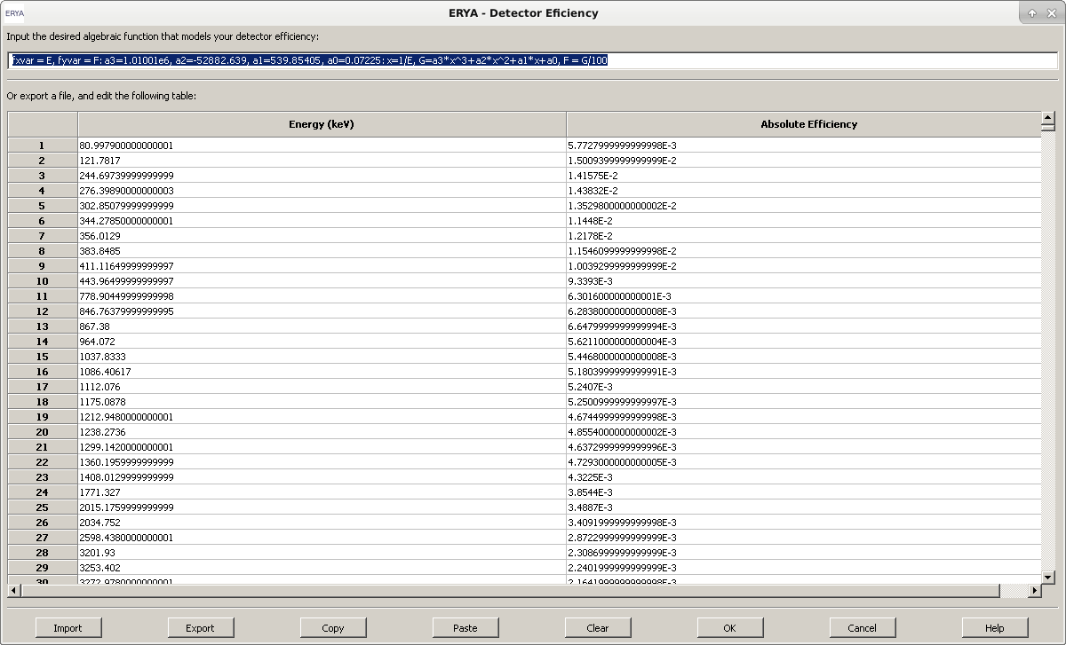To manage the Detector profile, open the widget from Databases>Detector Efficiency, and then the following dialog panel will open.

This is straightforward to use, with all possible operations clearly visible. Additional information can be retrieved from the on-line help, by clicking the “Help” button.

This editor combines a text field, intended for the user to code an algebraic function, describing the variation of the Detector Efficiency with Energy, and a two-column table to fill any experimental values for the Detector Efficiency that will serve the same purpose.

Both fields can be filled on the built-in editor, and stored in the profile file. However ERYA will choose the function field by default, if it is correctly defined, and will ignore the table.

In absence of the algebraic function, the user should fill the highest possible number of experimental values on the built-in spreadsheet editor. The accuracy will be better if the difference between energy values is smaller, since the program will make a segmented linear interpolation along the values of the efficiency table..

**Managing the Detector Efficiency profile file**

While it is possible to use the built-in spreadsheet editor to fill efficiency data, the user can also import any compatible experimental values from external files.

The native Detector Efficiency profile file is a XML file, which stores the experimental efficiency points, and the additional user defined efficiency function. This file has a **epsd** extension.

It is possible to export and import the experimental efficiency (the custom function is discarded) to or from an ASCII file, required to be a full numerical two columns of data, separated by a space or tab.

Excel files are also supported in a similar way. The Excel file should be a simple sheet with only two columns of numbers. There is no problem in adding labels on the first row, which will be ignored. Any graphics or special attachments to Excel file will also be ignored. [The ERYA’s Excel file filter only supports Excel 2007 and beyond version files (with **xlsx** extension), and only recognizes cells with names and numbers.]

It is also possible to copy the table contents to a text or spreadsheet file, but this feature is very error prone. In order to copy the table, select the contents from the editor, and click “Copy”, then paste to your text editor. The reverse is similar, once copied from the source, it requires to click on the first target cell, and then click “Paste”. If necessary, clear the built-in table by clicking “Clear”.

Any edition can be stored by using the “Export” button, and then choose among the native XML (epsd), ASCII (txt) and Excel (xlsx) formats. You should overwrite the start-up Detector Profile, as you defined in the initial setup and described in the “Quick Setup” chapter, to make permanent changes.

Stored and additional Detector profiles can be loaded from the “Import” button, and they will overwrite the previous content on the editor.

In order to make modifications valid only for a session, after the alteration of values made by importing or filling up the spreadsheet, the user should click “OK”. After finishing the session, the changed values are lost, since the profile file was nor changed.

Hitting the “Cancel” button, will discard any edition.

**Custom Efficiency Function**

The optional algebraic efficiency function is implemented in ERYA as a input line box for the user to code a custom function, overriding the table.

In technical terms, is a trimmed-down macro language designed to code custom functions without needing to recompile the application for different kinds of functions. The functionality and syntax are inspired form the BASIC language dialects found on programmable calculators. A more detailed documentation about the language are included on the program’s on-line help.

By default a function will be inscribed in the upper window of the Detector Efficiency widget, as, for example:

**fxvar = E, fyvar = F: a3=-2078.4, a2=-312.84, a1=5.006, a0=0.001: x=1/E, F=a3*x^3+a2*x^2+a1*x+a0**

It represents symbolically the following function:

$ϵ_{\text{abs}}\left(E_{γ}\right)=0.001+5.006E_{γ}^{−1}−312.84E_{γ}^{−2}−2078.4E_{γ}^{−3}$

The special commands **fxvar** and **fyvar** followed by the assignment sign (=) and the variable name, are used to define the independent and dependent function variable, respectively. The following entry, separated by commas (a3 to a0) , refer to the coefficients of the function. The final entry defines the function after redefining the independent variable.

If the user is willing to use a function of the type referred above, then he (she) only has to modify the coefficients overwriting the ones in the window. If more coefficients or other type of function is required, it must be typed in the window, respecting separation spaces and symbols, as the ones shown in the example.

**Stopping Powers**

As the Detector counterpart, the Stopping Powers widget follows the same layout and functions, albeit exists some key differences.

ERYA-Bulk inherited the original Ziegler’s Parameters model from the previous LabView ERYA software. In order to expand from the old software limitations, ERYA now supports custom algebraic functions and the SRIM tables.

The Stopping Powers is opened from Databases > Stopping Powers:

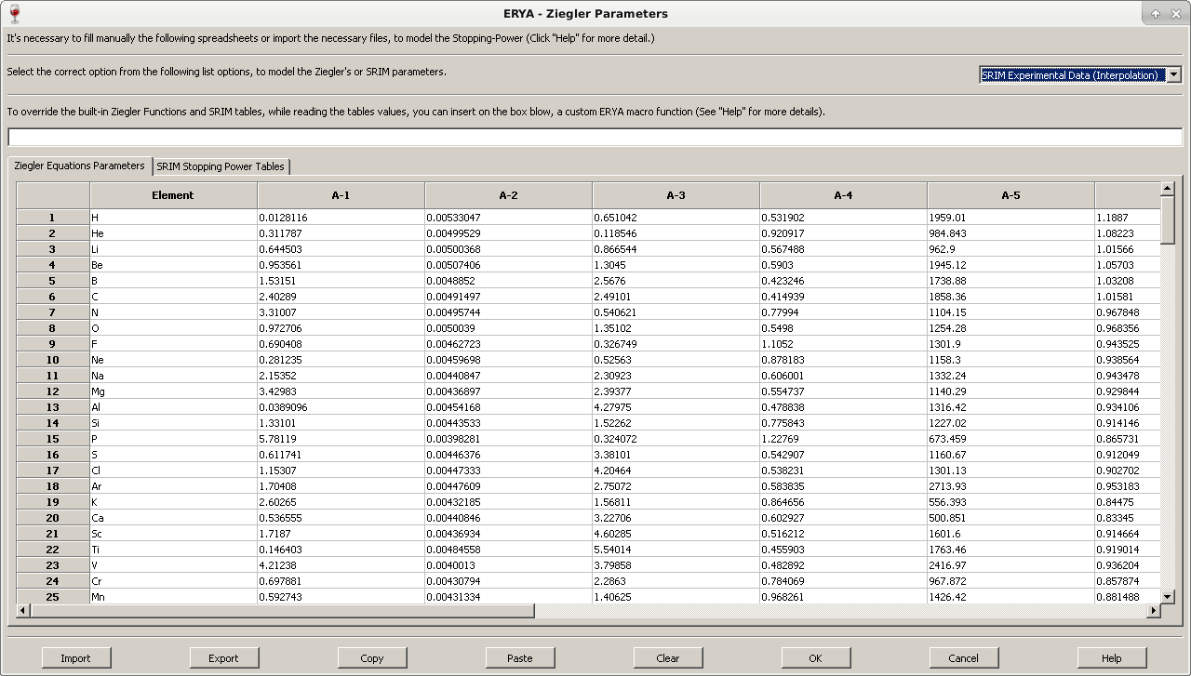

The Stopping Powers profile file stores not only the Ziegler’s Parameters derived from 1977 and 1991 models, but also the converted SRIM tables for all elements, and a custom ERYA macro.

The data is stored in a XML file with **epsz** extension and contains all data editable by this panel.

The top pull-down menu selects the stopping-power model applicable to all numerical simulations. The first two options corresponds to the Ziegler’s model (either the 1977 or 1991 equations, hard-coded on program.), that requires to fill the “Ziegler” tab with the parameters on the built-in spreadsheet as displayed on the figure. This corresponds to the original LabView ERYA stopping-power model.

The algebraic function and SRIM options are explained with more detail on the next sections.

**Defining a Custom Stopping-Power Function**

The user can define a custom function for the stopping-power in function of energy. To use this functionality, select the “Custom Function” mode on the Stopping-Power mode menu, and fill the required macro code on the input box. When correctly defined, ERYA will make a syntax check and validate the custom function code.

ERYA expect the custom function represent the stopping-power on 1015 at*eV/cm2 units in function of energy in keV.

The coding standards of the custom stopping-power function are the same of the Detector’s efficiency, and the only real difference is a third obligatory command called **fnvar** that create a vector of 16 elements. The first variable of such vector had the same name as defined by the assignment sign (=). The other 15 variables are simply the same name base, appended with a number from 1 to 15.

This means that if the user defines a *zn* variable as **fnvar**, as displayed here:

**fxvar = x, fyvar = y, fnvar = zn : …**

Then the following variables are created on the interpreter’s memory stack: *zn, zn1, zn2, …, zn15*.

All 16 variables created by the **fnvar** command will be used by ERYA to copy the entire line of the Ziegler’s Parameters spreadsheet automatically to those variables:

► The first base variable will be the Element’s Atomic number;

► The next 12 variables will be the A-1 to A-12 parameters;

► The variable with *13* suffix will be the Atomic Mass.

► The variable with *14* and *15* suffix is not used on ERYA-Bulk, and values “1”.

**Example:** To use the following function, defined by the combination of two expressions as follows:

$\begin{aligned}S\left(E\right)=S_{low},0<E<1000 \\ S\left(E\right)=\frac{S_{high}S_{low}}{S_{high}+S_{low}},E≥1000 \\ S_{low}=a_{1}E^{a_{2}}+a_{3}E^{a_{4}};S_{high}=\frac{a_{5}}{E^{a_{6}}}ln\left(\frac{a_{7}}{E}+a_{8}E\right)\end{aligned}$

The constants a1, … , a8 are placed on the Ziegler’s Parameters table and ERYA will load automatically according to the element’s atomic number line.

Using the *fnvar* command, all necessary constants are created from the base variable “a”.

Applying all ERYA’s Macro language rules, the custom function should be written as the following:

**fxvar = x, fyvar = y, fnvar = a : low = a1*x^a2 + a3*x^a4 , high = (a5/x^a6) * ln (a7/x + a8*x) , y = (x>0) * (x<1000) * (low) + (x>=1000)*((high*low)/(high+low))**

Since the two auxiliary functions depends from the independent variable, and pass their values to the main function, such algebraic expressions should never be separated by the colons symbol.

ERYA’s Macro interpreter stores the last expression (including all terms separated by commas) after the last colon, as the main function, and considers everything left as fixed constants.

**Warning:** If the user define, wrongly, the example with:

**fxvar = x, fyvar = y, fnvar = a : low = a1*x^a2 + a3*x^a4 , high = (a5/x^a6) * ln (a7/x + a8*x): y = (x>0) * (x<1000) * (low) + (x>=1000)*((high*low)/(high+low))**

The interpreter will store the “high” and “low” functions as fixed valued constants, and give wrong results for each valued “y” in function of “x”, since the auxiliary functions was incorrectly declared as constants.

Piecewise functions on ERYA, such as this example, should be defined with conditional terms, that use simple relational expressions inside parenthesis, and multiplied by each piecewise function inside parenthesis too. All piecewise functions are joined together by sums.

**Note:** This coding standard are derived from the BASIC language from programmable calculators, which ERYA follows.

**Note:** On most common uses, the Custom Stopping-Power Function are used mainly on tests, where it may be useful to code a constant stopping-power to certain samples.

For example, to define a constant stopping-power of 1.77*1015 at/cm2, just write the following code:

**fxvar = x, fyvar = y, fnvar = zn : y = 1.77**

Or alternatively, write with a symbolic constant on function:

**fxvar = x, fyvar = y, fnvar = zn : c = 1.77 : y = c**

**Using the SRIM Stopping-Power Tables**

To manage the converted SRIM tables, select the pull-down menu to “SRIM”, and select the “SRIM” tab to edit the chain of spreadsheets in a fashion similar to the Detector’s Efficiency.

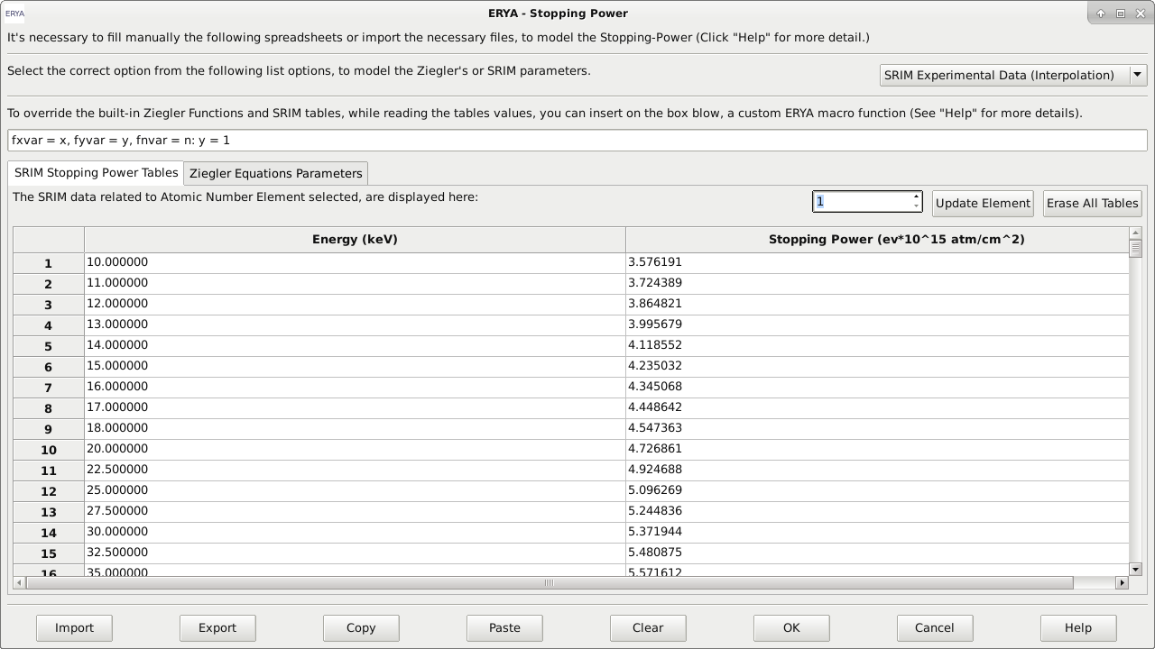

The SRIM’s Spreadsheet editor can only display an element each time, even several elements reside in memory, on the original file. In order to display other tables, just change the numerical value on the switch-box that corresponds to the Element’s Atomic Number.

Any edition of the selected SRIM table will only be stored in memory, if the user click “Update Element” button. The other “Erase All Tables” button will delete all tables from memory.

If the user wants to update the tables from the original SRIM® stopping-power ASCII files, he must follow the import instructions on the next section.

All SRIM tables will have several experimental values for the stopping-power in ev/1015 at/cm2 units versus energy in keV units; interpolation between tabled values will be done during the numerical calculation.

**Import and Export Stopping Powers to different formats**

The native Stopping Power file is a XML file with **epsz** extension. If the user desires, it is possible, like on the Detector widget, to import and export the current built-in table content to a text file or an Excel file.

►ERYA can parse directly any unedited SRIM Stopping-Power output files generated by SRIM® software. (**And this is highly recommendable, to avoid conversion mistakes**)

When the Import button are activated with ASCII import, and ERYA detects that is a SRIM Stopping-Power table, it will convert to the correct Element’s atomic number table on the SRIM tab, since all necessary information like the atomic number, unit conversion constants and some additional information are directly available.

**► ERYA cannot save stopping-power tables back to SRIM® tables file formats.**

Instead, it will export the active element’s stopping-power directly to an ASCII file, exactly as ERYA displays.

**► When the user exports to ASCII files, the program will take attention with the selected tab mode forehand**, this means that will apply the Ziegler’s rules when the tab is the Zielger’s Parameters, and the SRIM’s rules when the corespondent tab are the SRIM ones. In particular, the active atomic number SRIM table are also taken account.

- If the user opt to export Ziegler’s Parameters to an ASCII file format, any custom “Element” names are replaced to their row number. When imported from an ASCII file, it will renames to the chemical symbol, since ERYA contains an hard-coded dictionary of all elements.

►**When the user import a raw numerical data table** that should be a new Ziegler’s Parameters table or a stopping power interpolation data as ASCII, the user should select the Ziegler’s tab or the correct atomic number’s on the SRIM tab first **before importing the file.**

**- Without make such previous verification** ERYA may deliver an error, or erroneously validate the import.

►The same cautions and procedures are also applied when export or import Ziegler’s and SRIM tables using Excel Xlsx files, since ERYA requires to know manually the element’s atomic number if the source file corresponds to a SRIM table.

- When the user export an Excel file with Ziegler’s Parameters, the Elements names are also stored on Excel files.

**Element Database**

The Element Database contains all the necessary elemental parameters, including cross sections for the numerical calculations.

To open the Database Manager, just click on Databases > Elements menu:

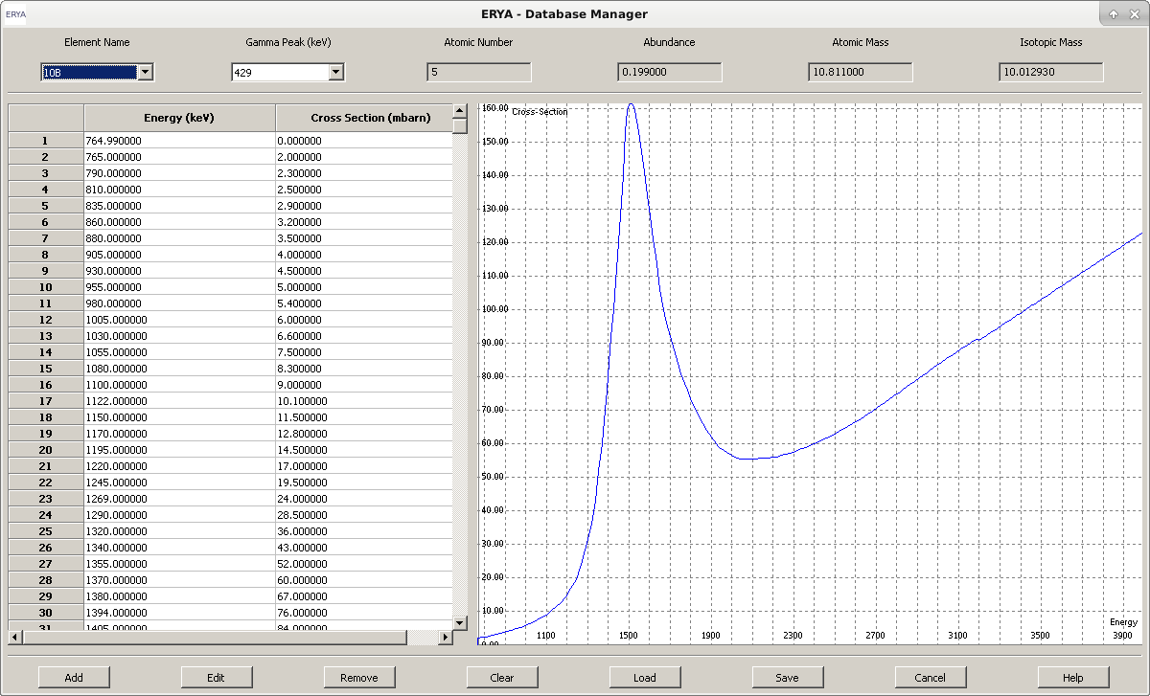

Using this tool, it is possible to handle the contents of one database at a time (normally the default loading database when ERYA starts).

►By clicking on “Element Name” pull-down box, the selected element/isotope will refresh the “Gamma Peak” pull-down box, and then the user can select the available gamma emission peak for that element.

For each Element/Gamma pair, a read-only Energy/Cross-Section table and graphical plot will be drawn. Up to four element physical proprieties will also be displayed.

The graphic plot can be zoomed or fitted to the screen, using the mouse. Additional commands are available on a right-click menu.

**Editing the Elements Database**

A common operation on database management is the possibility to add or edit elements.

►To edit an element content, select the desired element and gamma peak from the *Database Manager* dialog panel, and click on “Edit”button, that will open a new dialog:

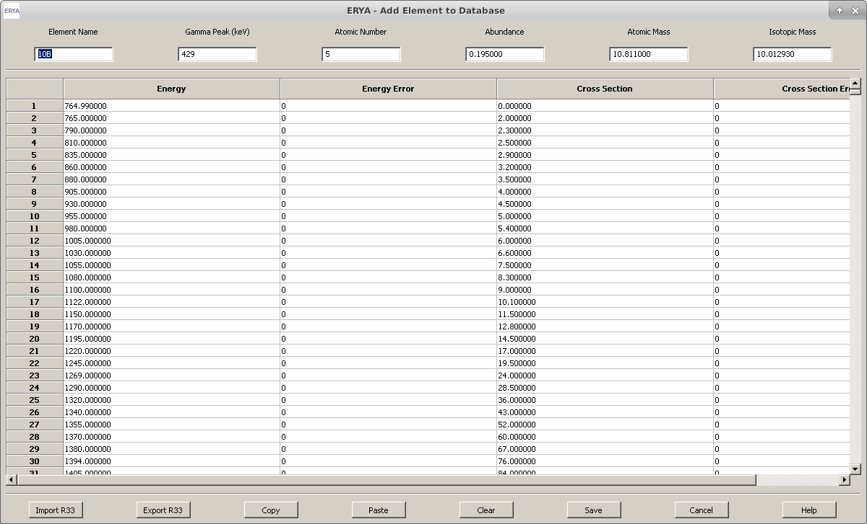

**Note:** The same widget is displayed when the user click on “Add”, but it will open a blanked dialog. Further explanation about elements editing will be detailed later.

►To delete an element, select the element and gamma peak to be removed, and click “Remove”.

ERYA will ask if you want to delete the selected element and gamma. Notice that the changes are only permanent when the edited database is stored on disc.

►Select “Load” to load a database from a file. The current database on memory will be replaced.

►To store a database from memory to disc storage select “Save”. When overwriting the default loading database, the changes are permanent.

►To discard any editions made on the current database, hit the “Cancel” button.

**►**Further information is available at on-line help dialog (“Help”).

**Adding/Editing new Elements**

The user can create new elements or editing new ones using the adequate controls on the *Database Manager*, that will open a new dialog dedicated to the edition of all necessary parameters.

► Any element should have a unique name and gamma peak emission value. There’s no harm to add suffixes to the Element’s name, as long do not use unsupported characters. (See warning below.)

Every element (isotope) register must have an Atomic Number, its Abundance (ranging from 0 to 1), its Atomic and Isotopic Mass.

► The element’s cross-section spreadsheet can me manually typed, filling the four columns for the experimental cross-section and energies, and their experimental uncertainties. The energy should be placed in keV units, and the cross-section (total cross section) in milibarns.

►The need to manually type on the built-in spreadsheet editor is very limited, as the cross section values may be filled in by importing them from file sources, using the “Import” button to enable direct file parsing of some file formats.

ERYA allows import and export of R33 (as those in IBANDL), ASCII and Excel’s xlsx files, where the latter require additional options to make a successful import, due to the requirement to convert units.

**Warning:** ERYA will check all physical parameters values written on top window, when the user export or save the new element register to the database.

All of them are pure numerical values, except the Element Name that had own strict rules.

If an Element Name contains spaces or any character that was not a number or a Latin letter, although an underscore “_” are accepted, ERYA will warn the user to fix the error.

**How to Import from External Files:**

To import cross-section data from external files, select “Import”, then select one of those models:

► **R33 Import:**

Select an **r33** format file, for example an IBANDL file, and ERYA will parse automatically without additional information.

Notice that if the file contains ambiguous data, or incompatible units, it will deliver an error message, aborting the whole process.

► **ASCII files import:**

Usually are text files that contains two columns of numeric data, and additional non-numeric lines of text.

When ERYA tries to parse such ASCII files, it will open an additional dialog asking the original cross-section units (milibarn or barn), or if the cross-section is differential or total. If ERYA fails to parse ASCII files due to the presence of non-numeric data, repeat the import procedure while select an additional option on the same import dialog to ignore any lines that are non-numeric data.

Once the parsing of the source file is completed, only numerical data related to the cross-section are placed on the built-in spreadsheet.

**►Excel files import:**

Import cross-section data from Excel files (as long it is saved on Excel 2007 and beyond versions with xlsx extension) is also possible, while opens an additional dialog to ask about the original cross-section units in the same manner on ASCII case, and the import profile with three different options:

- First option – leaves ERYA to select automatically the import format from the original data. This is the recommended case, unless ERYA fails to decode the original Excel file structure.

- Second option – force ERYA to use the two columns import format, where the energy is placed in the first column, and the cross-section in the second column.

- Third option – force ERYA to use the four columns version, where the energy is place in the first column, and the cross-section in the third column. The second and fourth columns are reserved for the energy and cross section measurement uncertainties.

►To avoid import errors from Excel files, apply this rules:

- Store every relevant information on the first spreadsheet page, and group all relevant data on a single compact matrix block. It is not necessary to place everything from the first cell.

- Any rows with non-numerical data, or anything beyond the fourth relevant column are ignored.

**How to Export to External Files:**

To export the cross-section data from the current Element data, select “Export”, and select one of those three models:

► **R33 Export:**

ERYA can store the cross-section and some elemental physics parameters (including the name and gamma energy) on r33 (IBANDL) file format. The cross-section is given as total in milibarn units.

The comments fields contains ERYA software version, and the six original element references. If re-imported the r33 file again, such fields will be ignored.

Notice that ERYA will assume the reaction not change the nuclear species, requiring manual editing of the exported IBANDL file to fix some inaccuracies.

► **ASCII files export:**

ERYA will export only the cross-section data to a text file with two column of numeric data, without any additional information. The total cross-section are converted to barn units and energy to keV.

**►Excel files export:**

ERYA will store only the cross-section as a single sheet numeric spreadsheet of data. The first row contains the original row labels of the ERYA’s cross-section editor. When selected this format, the program will ask to choose between a two or four-column file export, but it will always stored on total cross-section in milibarn units.

**A Simple Import Example:**

To explain the basic work-flow of creating or editing the Element’s Database, we will show how to create a new element using an IBANDL file, and make a backup to a file.

**1.** Go to IBANDL website at: [https://www-nds.iaea.org/exfor/ibandl.htm](https://www-nds.iaea.org/exfor/ibandl.html)

**2.** Select a nucleon, which can be any of the list, but choose a proton projectile (ERYA only support proton projectiles). It is highly recommendable to filter data types by PIGE only, and select the ones with “mb” or “tot” units format.

►Selecting IBANDL files with non-supported units or non-proton projectiles will be rejected by ERYA, warning the user about the import failure cause.

**3.** Save the relevant cross-section files as r33 files. (Click the “Save” button from the web-page.)

**4.** Start ERYA, then open the *Database Manager*, and finally, click “Add”.

The Element Editor widget, which should be blank, opens.

**5.** Click on “Import” button to load the file dialog widget. Then select the “IBANDL” file format from the file dialog, and pick the correct IBANDL file.

If everything goes right, the cross-section data will be placed inside the built-in spreadsheet of the Element Editor automatically. Usually all necessary unit conversions are made automatically, since the IBANDL file contains all necessary conversion parameters explicitly declared.

Since the IBANDL file contains some additional data, it will also place some of the six Elements parameters on the top window widget.

►Normally, the chemical or isotope symbol and their atomic number will be placed automatically.

►When ERYA read a chain of numbers from the Gamma Peak energy, it will always place the first declared value.

►On this example, the widget fills the following data, as display here:

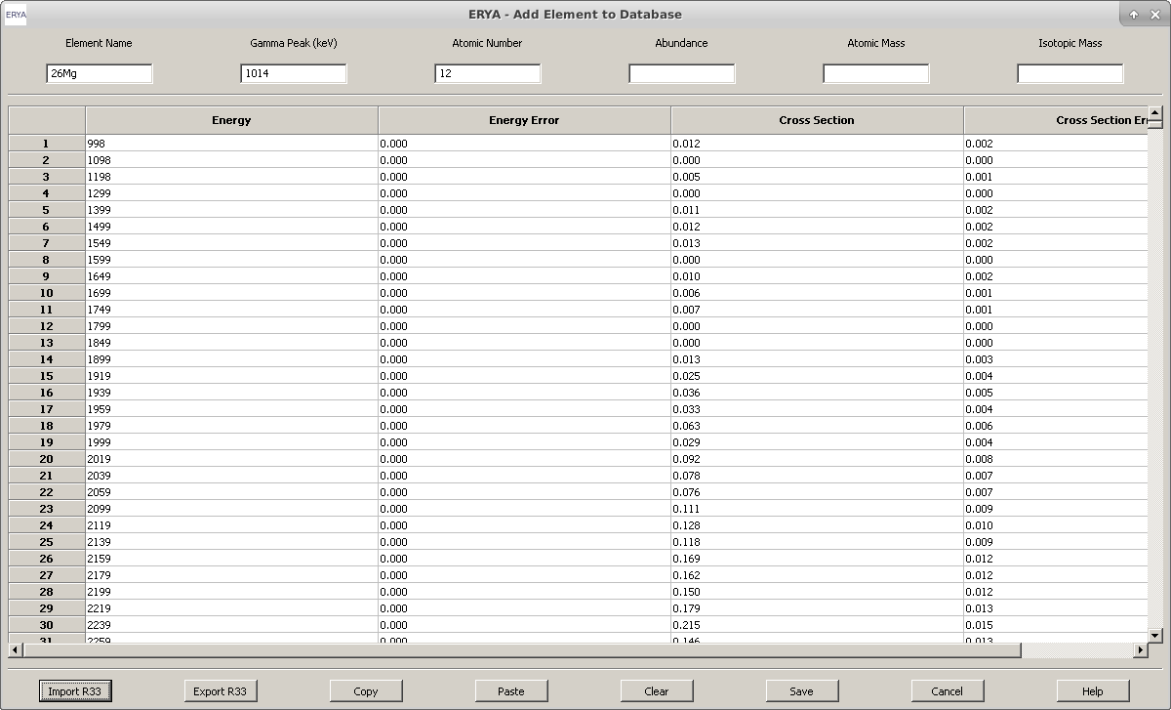

**6.** Using an isotope table, or an online reference material, fill the remaining gaps, like Abundance or the Isotopic Mass.

**7.** Click “Save”, and the new Database entry will be sorted and added.

The new element information will be displayed on the Database Manager.

**Warning:** If ERYA detects another Database register with the same Name and Gamma Peak, it will asks to accept or abort. In case of acceptance, it will add a number suffix after an underscore (<x>_0, <x>_1, … ).

**8.** Repeat the steps 4 to 7 to add another entries.

**9.** Once returned to the main Database Manager, click on “Save”, and select the start-up Database file, if you want to make permanent changes, or choose another name, if you want to keep the custom database separated.

**10.** The new elements are now available to use.

How to make a PIGE Analysis

The main purpose of ERYA is to make an analysis of a in-depth homogeneous sample, in order to determine its composition in terms of its elemental mass concentrations, providing the possibility to fit the experimental values to the simulated ones, for several elements simultaneously.

In the last chapter we described the databases of the input data. Now we will address the additional steps to proceed to the calculation.

Fi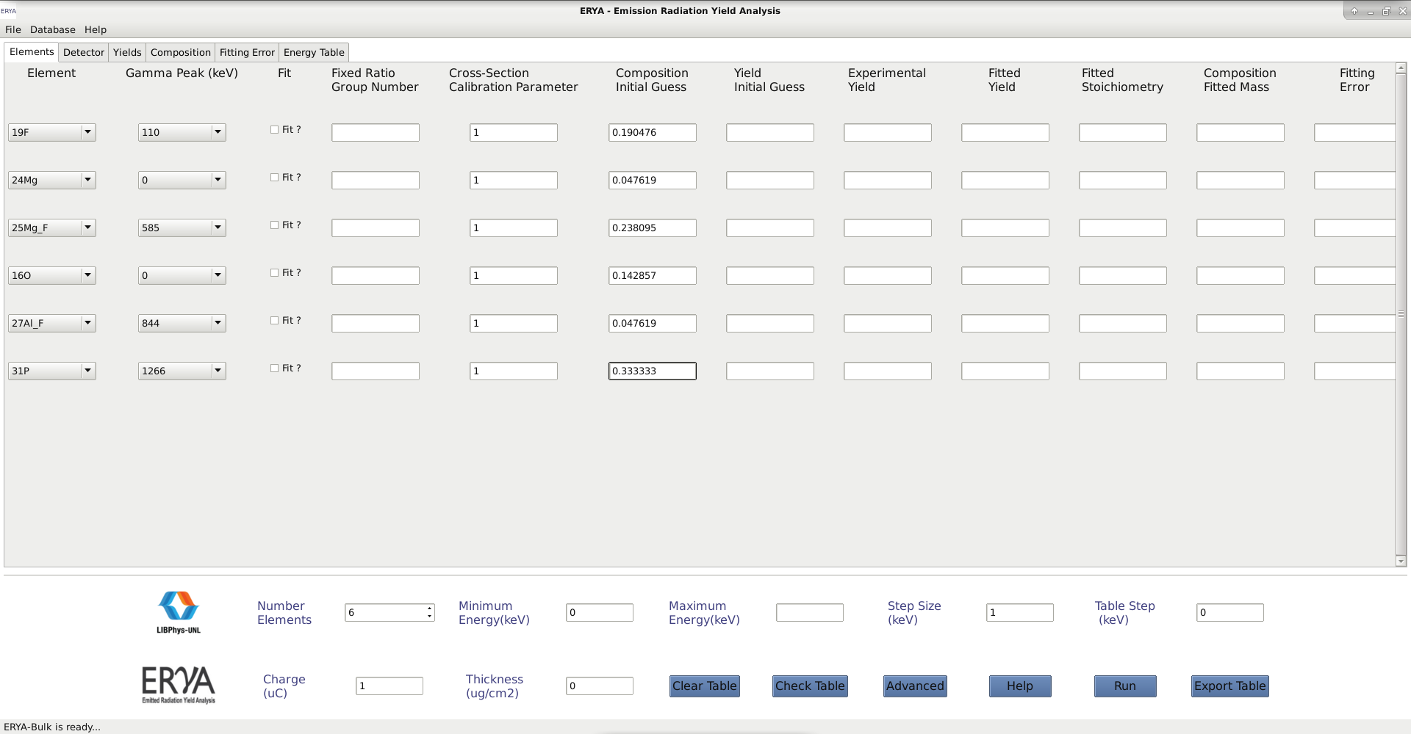g. 1 Detail of the main screen interface.

**How to define your Sample**

The user should fill all information related to the sample composition using the tools provided by the main screen interface, following the steps below.

1. Select the number of elements (first entry of the bottom bar), which will lead to a corresponding number of table lines.
2. In the first column of this table select the element names from the pull-down menus.
3. In the second column select the corresponding gamma-ray line.
4. If the sample contains a well defined chemical compound, then an unique positive integer should be assigned on the fourth column, for all elements belonging to such a compound.

**Example:** If you have a Li2WO4 compound mixed to the sample, assign the three elements (Li,W,O) to a Number Group “1” or other number of your choice.

**Note:** Unsigned elements will have a Number Group equal to zero by default, and ERYA treats them as independent elements.

1. The Initial Composition column may be filled with numeric values or algebraic expressions that the ERYA macro interpreter will evaluate to numerical values automatically.

The following examples are valid:

**1 – 0.2** for **[0.8]**

**1/5** for **[0.2]**

**1 – (1 / 2 + 1 / 3 )** for **[0.166667]**

It is also possible to use symbolic variables, as long the final arithmetic expression is the last block of code after the rightmost colon (:)

**a = 1 , b = 5 : 1 – a / b [0.8]**

Any column entry empty will be perceived by ERYA as the default “1” value.

Values entered in this column may be higher than 1 as once ERYA begins a numerical calculation, the entire column will be renormalized to a sum equal to 1.

1. Another important column is the cross-section calibration parameter, which default is “1”.

Systematic uncertainties related to cross section values, detector efficiency, beam charge collection, may be minimized by calibration of the experimental set-up made with known samples, leading to calibration parameters for each isotope (see for example ref. 1).

**How to define your experimental set-up**

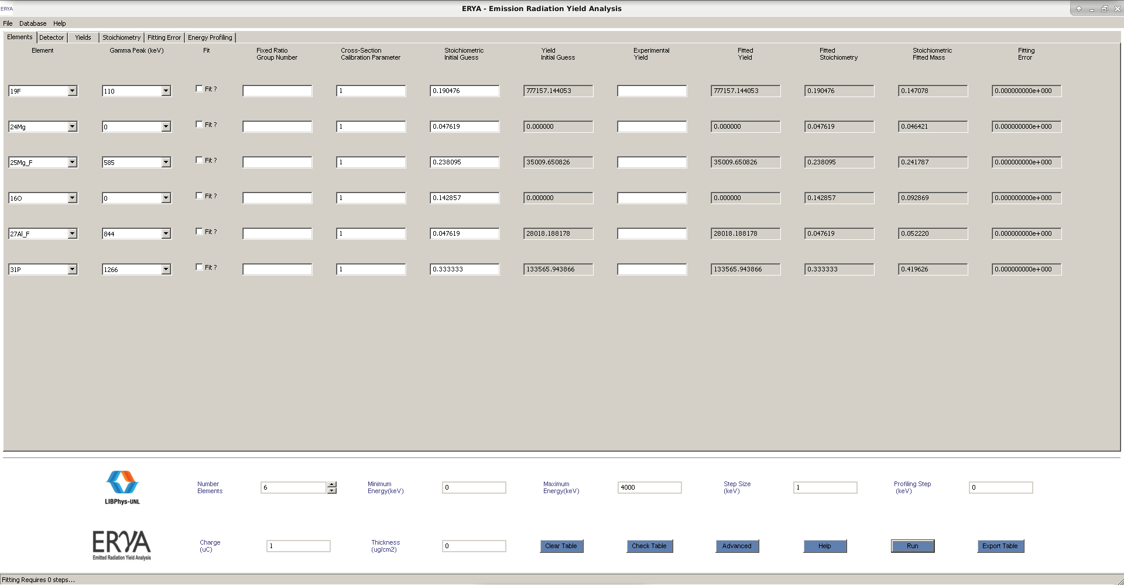Most of the input needed about the experimental set-up must be filled in the bottom bar of the main screen interface:

1. Maximum Energy – proton energy used for the analysis.
2. Minimum Energy – the energy cut-off for the sample integration. This can be zero, or below any initial energy referenced by the element’s cross-section, although ERYA are actually summing zeros until reach points that had non-zero values for the cross-section.
3. Energy Step – The integration step between the minimum and maximum energy values defined earlier.
4. Table Step - Evaluate an additional yield table making a sequence of integrals between the minimum energy and intermediate values until reaches the maximum energy by the step defined here. All integrals uses the Energy Step, but is meaningless to create a table with steps lesser than the integration energy steps. Set zero to skip this table.
5. Charge – fill in μC units.
6. Sample thickness (μg/cm2) – set to zero for a thick sample (wider than the proton range in the sample); enter the thickness of the sample for non-thick samples.

**►**Now click “Run” to get the theoretical yields, which will appear on the correspondent columns of the main table. If the user select a non-zero value for the Table Step, then ERYA will evaluate all yields between the minimum energy until the maximum by this table energy step, and display the results on a numerical table on the last programs tab. The whole progress runs with an additional progress bar gauge window.

**How to Fit experimental results**

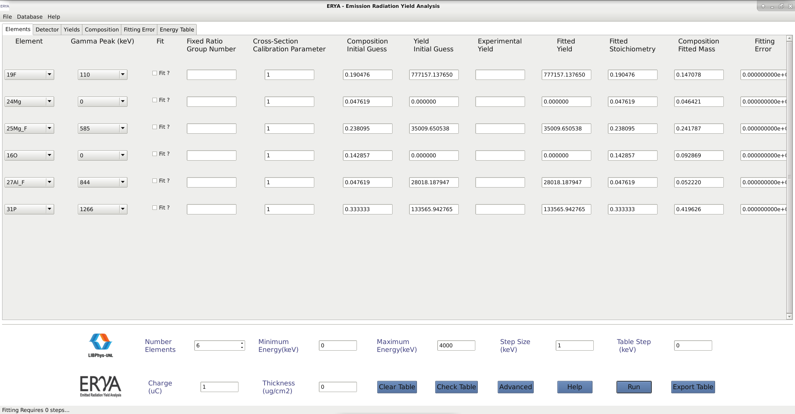ERYA provides a resource to optimize the composition of the sample in order to fit the experimental yields obtained for the sample analysis. This process needs the following steps.

1. Fill the “Experimental Yield” column with the experimental results.
2. Click on the third column the “Fit” check box, to choose the elements whose atomic (and mass) concentration you want to optimize. If for a given element there is no click, ERYA will keep for that element the atomic (and mass) concentration provided by the user.

This is helpful, mainly in relation to those elements for which there are no gamma yield and/or gamma cross sections, but for which the user knows (from PIXE, for example) their concentrations.

1. Elements which are part of a compound and for which the user has assigned the same Group Number (column four), will be treated as a single fitting variable. As long as all of them are chosen to be fitted, their relative composition ratios will not change.
2. To produce a table of yields once the fitting is done, set a different value for the Table Step than “0”. This will evaluate the yields between the minimum and maximum energy along the table energy step.
3. Now click on “Run” to start. ERYA will display a progress bar window during the fitting (indicating the current fit step until the maximum number of steps), that once obtaining a successful fit will pass to the table yield procedure with their own progress bar, if enabled earlier by the user at step 4.
4. Once finished all numerical calculations, ERYA will asks if want to copy the fitted sample composition to the initial column (If the user want to make a chain of successive fits), leaving the user choice the best option on their context.

**About the fitting procedure**

The program applies the Levenberg-Marquardt algorithm to perform the fitting procedure, and the fitting computation times depends on the number of fittings parameters, initial values and additional fitting settings. Normally, it takes few seconds for simple examples, and takes a little more time for samples with a large number of elements. At the bottom bar of the main screen interface the user may choose “Advanced” to access and modify details about the fit, such the maximum number of iterations and parameters of calculation precision.

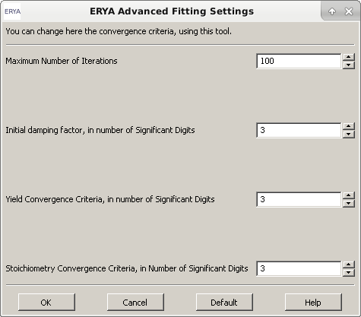

Maximum number of iterations – 100 (which is also the default value).

Initial damping factor (a damping gradient norm) – number of significant digits from 0 to 3 (default is 3),

Yield convergence criteria – number of significant digits from 0 to 6 (default is 3).

Composition convergence criteria – number of significant digits from 0 to 6 (default is 3).

Changing the default values in order to reduce precision can avoid unnecessary computation time for simple samples, but increasing the precision may increase the computation time with only a small improvement.

**Loading and Saving Results**

Once the numerical simulation ends successfully, the user can store the results, both the ones on the main screen and the table of yields if created, in two major file formats:

►Excel file (extension **xlsx)**, by clicking on the “Export Table” button and giving a name and directory location of the file.



►A XML file (extension **epz**) from File > Save As.

Opening output files in ERYA is only possible for native **epz** files. Once loaded, ERYA asks to run a new simulation with the initial values loaded from the file.

►You need Microsoft Excel 2007 or newer version, or a compatible alternative such LibreOffice or Google Sheets to open the ERYA’s own created Excel files.

Third party programs capable to save and load Excel 2007 files should read the files created by ERYA, as this program only use a few functionalities of this proprietary format.

**Example of a PIGE analysis**

Sample composition: major composition – calcium phosphate mixed with silica; minor elements – iron and gold; minor (trace elements) – lithium and fluorine. The user may have an idea of the composition given by other methods, as for example, PIXE, to use as a first guess.

PIGE spectra collected for 3600 keV protons. Gamma-ray available only for 15P, 28Si, 19F and 7Li. Corresponding yields obtained for 1.0 µC of collected charge.

Step 1. On the main interface (see below) introduce 8 for the number of elements and then choose the elements (as Ca, Fe, Au) and the isotopes with corresponding gamma-rays.

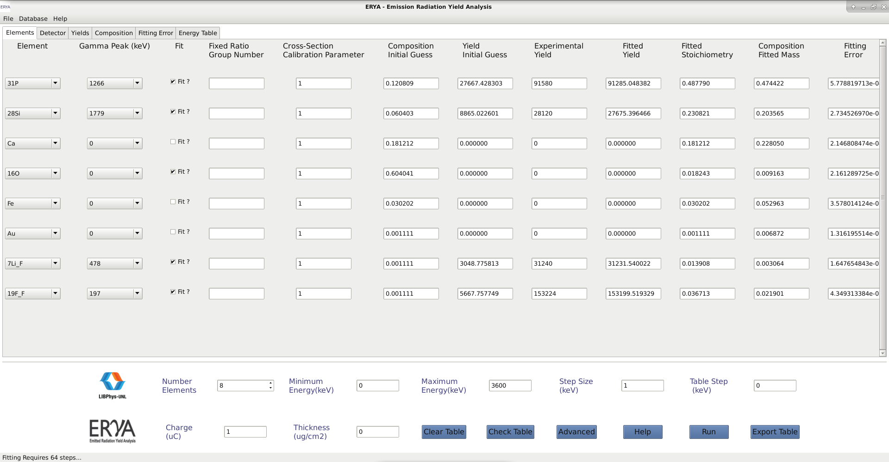

**Step 2.** As gamma-ray yields and excitation functions are available for 15P, 28Si, 19F and 7Li, check the boxes of column 3 related to these isotopes in order to fit. Every major element must also be chosen to fit, in order to obtain the adequate stopping power for the calculations. As no yields are given for these elements, which would constraint the fitting procedure, their number must be as small as possible, in order to get an unequivocal answer. In this example, Ca may be grouped with phosphorous (column 4 – assign the same number) in order to keep their atomic ratio fixed during the fitting and have one free parameter less. Oxygen may not be grouped with these because it is part of silica besides entering the phosphate composition and also may be linked to other elements. So it should be chosen to fit, but not grouped. In relation to Fe and Au which are minor elements, they should not be chosen to fit.

**Step 3.** If you have calibrated your PIGE experimental system and have calibration parameters for 15P, 28Si, 19F and 7Li, fill-in on column 5; otherwise fill in the number 1.

**Step 4.** Give in atomic fractions your initial guess of the sample composition column 6. You my use numbers higher than one. ERYA will renormalize the sum of the sample composition fractions to one.

**Step 5.** Enter the experimental gamma-ray yields – column 8. The yields of column 7 will be calculated by ERYA.

**Step 6.** Fill in the bottom bar of the main screen introducing maximum energy, step size (integration step), charge, thickness (= 0 for a thick target).



**Step 7.** Press “Run”. After the fitting procedure ERYA will fill-in information about fitted yields, fitted composition in atomic fractions, fitted composition in mass fraction together with its fitting uncertainty.



**Step 8.** Save the results, using the “Export Table” button, which store the data to an Excel file.

**Extra Step.** If the user would like to have the gamma-ray yields of the fitted isotopes as function of proton energy, he (she) must change the table step for the number in keV the user wants, a table with this data will also be provided.

**Extra Step.** In order to have less computational time (if needed), the usermay open the “Advance” button and reduce the composition and yield precision to two decimal places, and reduce the gradient damping to two decimal places too.

**Tip:** Since ERYA will ask to copy the fitted Stoichiometric values to the Stoichiometric Guess columns once done each simulation, the user can deselected the “Fit” flag for elements which have fitted yields and experimental yields very close to each other and then make another “Run”, now with less fitting variables, and less computational time.

Bibliography

**Note:** The research materials are the same of the LabView ERYA program.

- R. Mateus, A.P. Jesus, J.P. Ribeiro, Nucl. Instr. and Meth. B 229 (2005) 302.

- PhD thesis: "Análise de elementos leves por reacções nucleares com produção de radiação gama", Maria Micaela Leal da Fonseca, Faculdade de Ciências e Tecnologia da Universidade Nova de Lisboa (2010).

- PhD thesis: "Recolha Automática de aerossóis e a sua análise por técnicas analíticas nucleares", Rodrigo Clemente Velez Mateus, Faculdade de Ciências da Universidade de Lisboa (2003).

- J. F. Ziegler, J. P. Biersack, U. Littmark, in "The Stopping and Ranges of ions in Solids", Vol. 1, Pergamon Press, New York, 1985.

- SRIM website: <http://www.srim.org/>; J.F. Ziegler, Nucl. Instr. and Meth. B219-220 (2004) 1027.

- IBANDL website: <http://www-nds.iaea.org/ibandl/>

**Additional reference:**

- Ananth Ranganathan, “The Levenberg-Marquardt Algorithm”

- K. Madsen, H.B.Nilsen, O. Tingleff, "Methods for Non-Linear Least Square Problems".

- wxWidgets website: <http://www.wxwidgets.org/>

- wxWidgets 3.0 reference manual: <http://docs.wxwidgets.org/3.0/>

- wxWidgets reference book: “Cross-Platform GUI Programming with wxWidgets”, Julian Smart and Kevin Hock with Stefan Csomor, Prentice Hall (2005).

- wxMathPlot add-on: <http://wxmathplot.sourceforge.net/>

- LabView DataLog reverse-engeenering file structure reference: <https://sccn.ucsd.edu/svn/software/tags/EEGLAB7_0_2_6beta/external/fieldtrip-20090727/private/read_labview_dtlg.m>

- Excel 2007 file documentation: <https://www.codeproject.com/Articles/208075/How-to-read-and-write-xlsx-Excel-file-Part-I> ; <https://www.codeproject.com/Articles/210014/How-to-read-and-write-xlsx-Excel-file-Part-II>